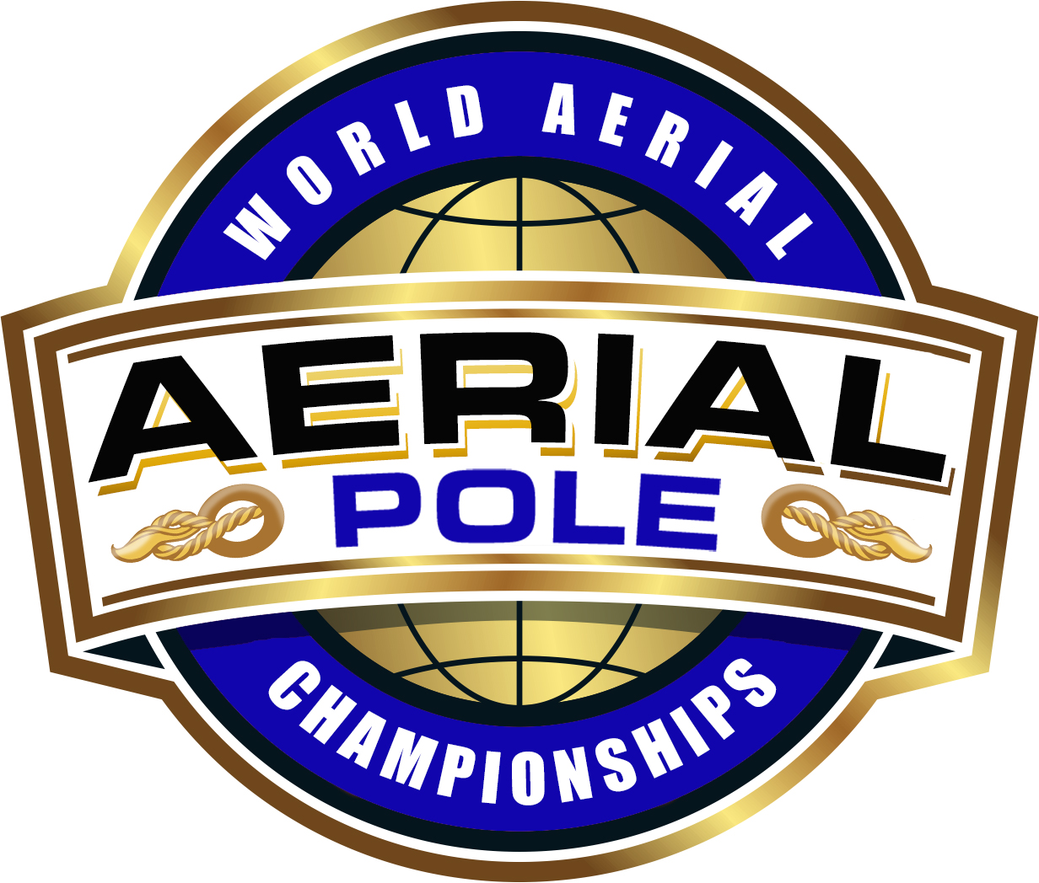
ARTISTIC & CHOREOGRAPHY SCORE SHEET
DISCIPLINE: | Pole Sport ☐ |  |  |  | Aerial Hoop Sport ☐ |  | Aerial Pole Sport ☐
Athlete(s): |  |  |  |  |  | Date:
Country: |  | Region: |  |  |  | Federation:
Division: |  |  | Category: |  |  | Judge Name:
Judging Criteria |  |  | Technical Value | Score |  | Comment
Artistic Bonuses |  |  | 0 = poor, 0.5 = fair, 1.0 = average, 1.5 = good, 2.0 = excellent
Originality of the overall presentation |  |  | Max +2
Originality of transitions in and out of elements |  |  | Max +2
Originality of Elements |  |  | Max +2
Interpretation of the music into the performance, body and facial expressions |  |  | Max +2
Stage presence and charisma |  |  | Max +2
Balance |  |  | Max +2
Flow |  |  | Max +2
Confidence |  |  | Max +2
Choreography Bonuses |  |  | 0 = poor, 0.5 = fair, 1.0 = average, 1.5 = good, 2.0 = excellent
Originality of choreography and composition of whole routine |  |  | Max +2
Originality of floor work |  |  | Max +2
SUBTOTAL BONUSES |  |  | +
Singular Deductions |  |  | Per time
Costume malfunction or distraction |  |  | -0.2
No logical beginning or end to the performance and or music and starting before or ending after music has begun or finished |  |  | -0.2
Causing distraction by uttering vocals |  |  | -0.2
Drying hands on costume, body, apparatus or floor and or adjusting hair or costume |  |  | -0.2
Overall Deductions |  |  | One time
Putting no effort or thought into the costume |  |  | -1
SUBTOTAL DEDUCTIONS |  |  | -
TOTAL

